**­companydata Data Layer Documentation**

Use the DataLayer similar to Project 2, the main difference is the constructors for each class. The ones that are available are shown at the end.

**Methods** (all throw an exception if there is an error, such as the requested object doesn’t exist)**:**

//Delete all Departments, Employees and Timecards for a company

//Returns the number of rows deleted

**public int deleteCompany(String companyName)**

//Insert a department

//Returns the inserted Department

**public Department insertDepartment(Department department)**

//Get all Departments for a given company

//Returns a list of Department objects

**public List<Department> getAllDepartment(String companyName)**

//Get a given Department for a given company

//Returns the requested Department

**public Department getDepartment(String companyName, int dept_id**)

//Get a given Department for a given company

//Returns the requested Department

**public Department getDepartmentNo(String companyName, String dept_no**)

//Update a Department

//Returns the updated Department

**public Department updateDepartment(Department department)**

//Delete a given Department for a given company

//Returns the number of rows deleted

**public int deleteDepartment(String company, int dept_id)**

//Insert an Employee

//Returns the inserted Employee

**public Employee insertEmployee(Employee employee)**

//Get a list of Employees for a given company

//Returns the list of Employee objects

**public List<Employee> getAllEmployee(String companyName)**

//Get the requested Employee

//Returns the requested Employee

**public Employee getEmployee(int emp_id)**

//Update an Employee

//Returns the updated Employee object

**public Employee updateEmployee(Employee employee)**

//Delete the given Employee

//Returns the number of rows deleted

**public int deleteEmployee(int emp_id)**

//Insert a Timecard

//Returns the inserted Timecard

**public Timecard insertTimecard(Timecard timecard)**

//Get all Timecards for a given Employee

//Returns the list of Timecard objects

**public List<Timecard> getAllTimecard(int emp_id)**

//Get the requested Timecard

//Returns the requested Timecard

**public Timecard getTimecard(int timecard_id)**

//Update a given Timecard

//Returns the updated Timecard

**public Timecard updateTimecard(Timecard timecard)**

//Delete the given Timecard

//Returns the number of rows deleted

**public int deleteTimecard(int timecard_id)**

//Close the connection

**public void close()**

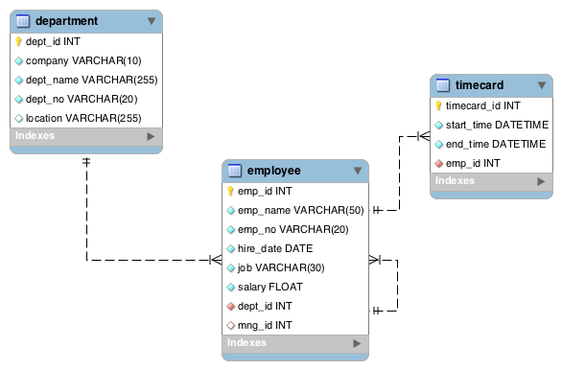

The **employee** table has two foreign keys:

1. mng_id references **employee**.emp_id
2. dept_id references **department**.dept_id

The **employee** table has an additional unique index of emp_no besides the the primary key

The **timecard** table has one foreign key:

1. emp_id references **employee**.emp_id

The **department** table has one additional unique index of dept_no besides the primary key

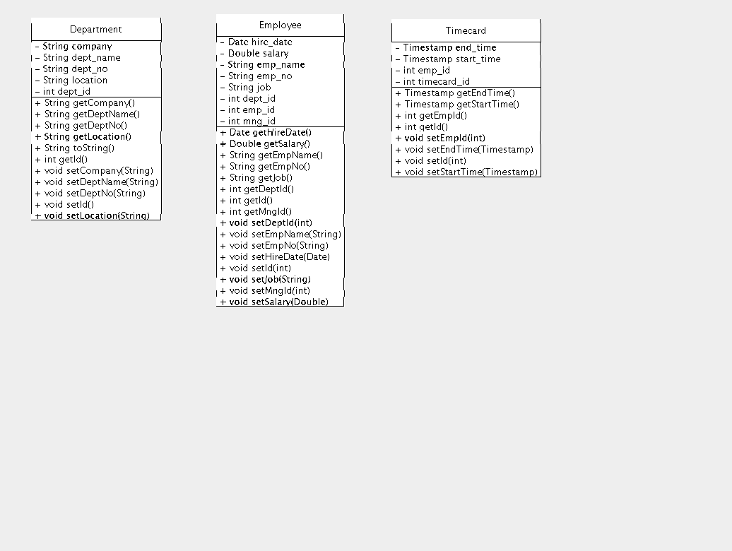

**Each class has constructors of**:

**Employee**:

Employee(String emp_name, String emp_no, Date hire_date,

String job, Double salary, int dept_id, int mng_id)

**Department**:

Department(String company, String dept_name, String dept_no,

String location)

Department()

**Timecard**:

Timecard(Timestamp start_time, Timestamp end_time, int emp_id)

Timecard()